**ASSIGNMENT 1**

**CREATING A DATABASE**

**QUERY:**

create database comp;

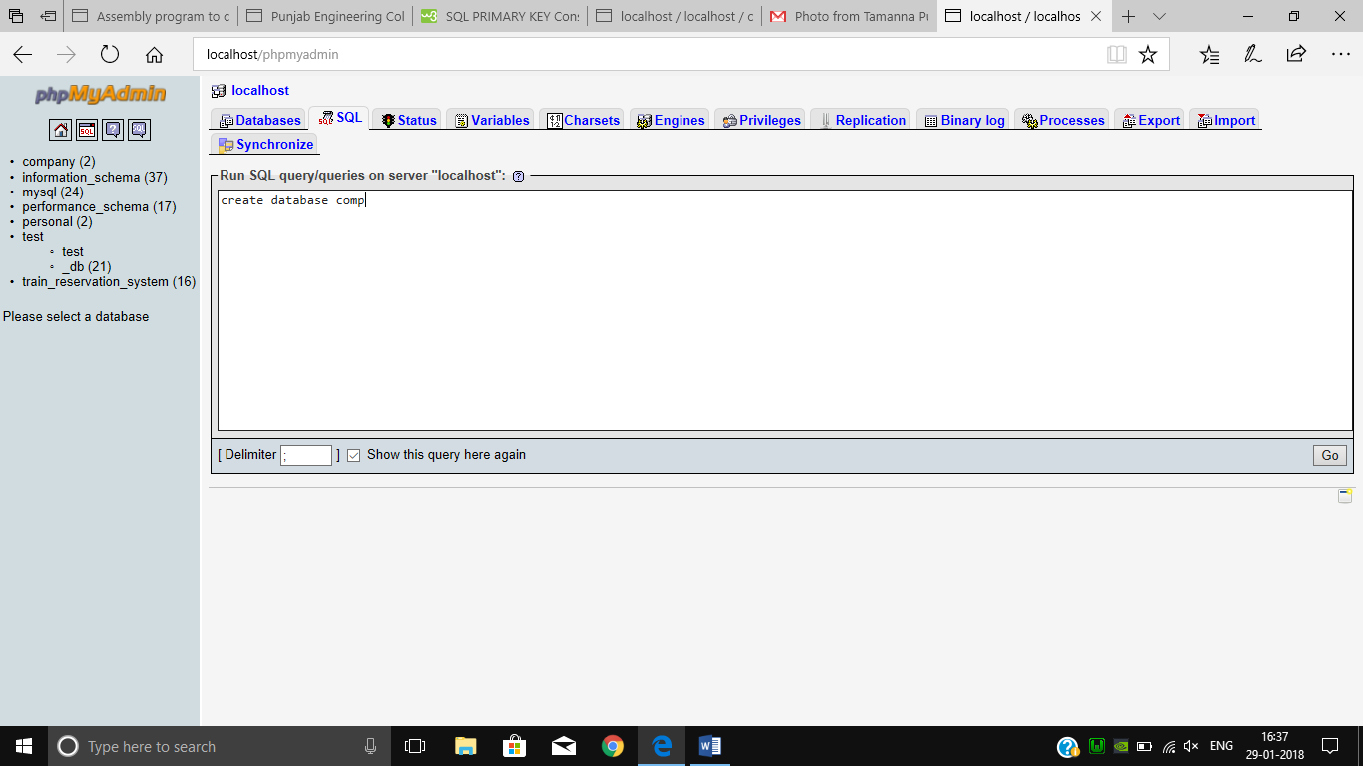

**2.CREATING A TABLE**

**QUERY:-**

create table table_name ( column_name1 datatype,column_name2 datatype,..) #this query is used to create a table in a database.

create table employee(empno int,ename varchar(20) unique,job varchar(20),mgr int,hiredate varchar(20),sal int,comm int,deptno int);

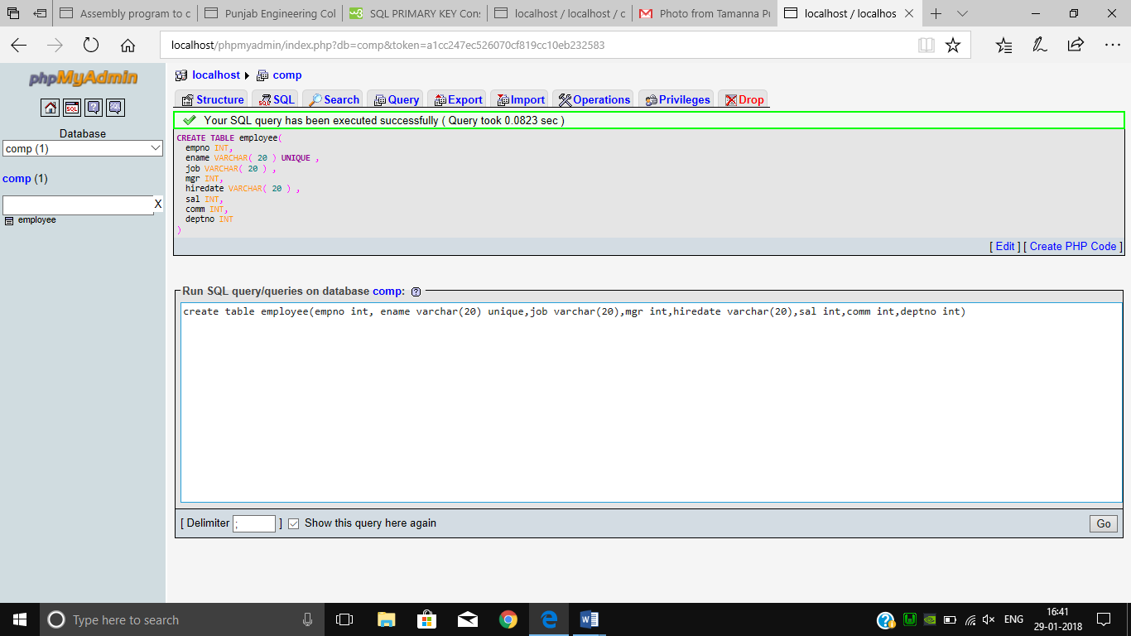

create table dept(deptno int,dname varchar(20),loc varchar(20));

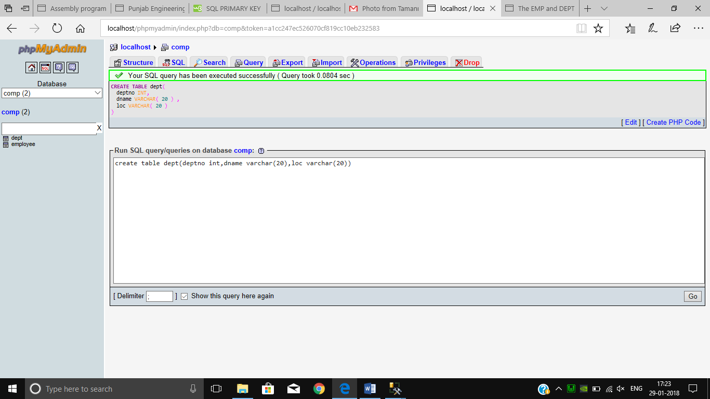

**3.INSERTING VALUES IN TABLE**

**QUERY:**

insert into table_name(column_names) values(…);

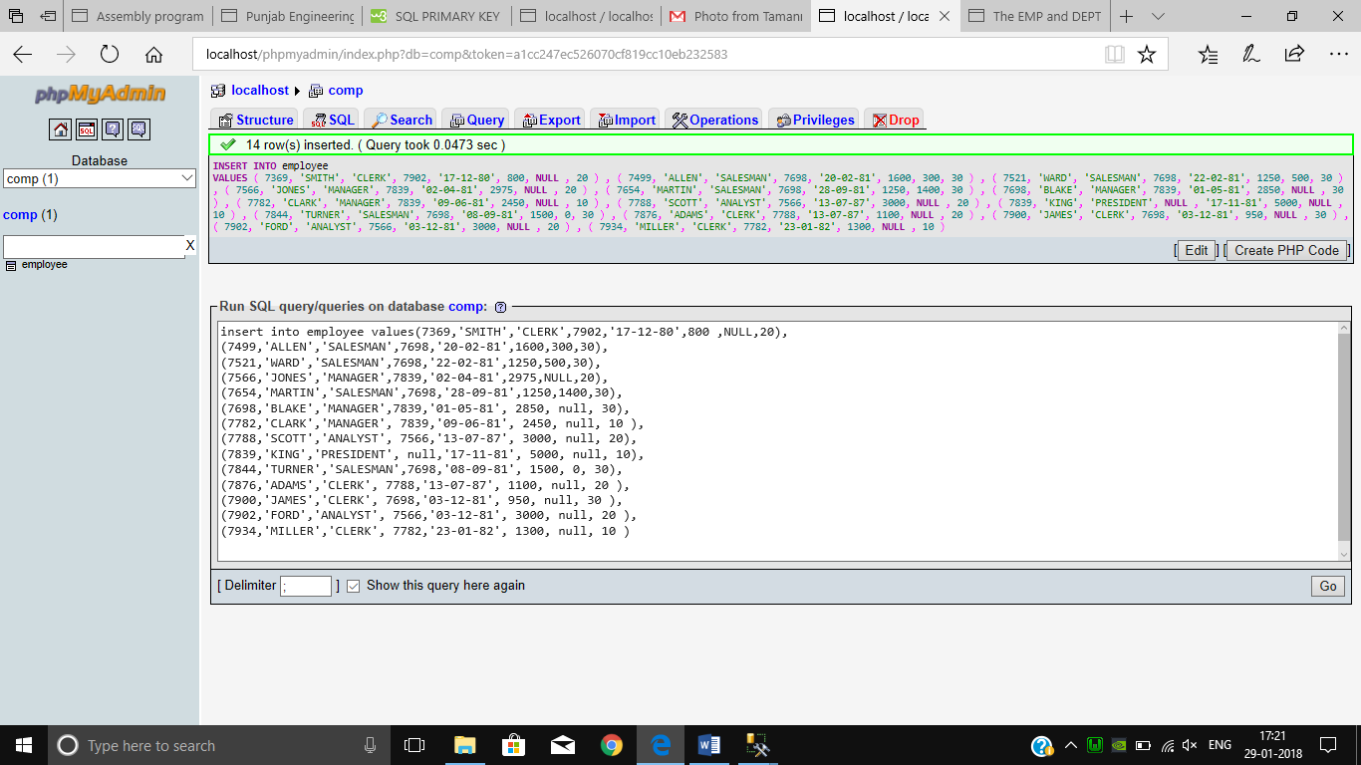

AFTER THE EXECUTION OF QUERY THE TABLE LOOKS LIKE.

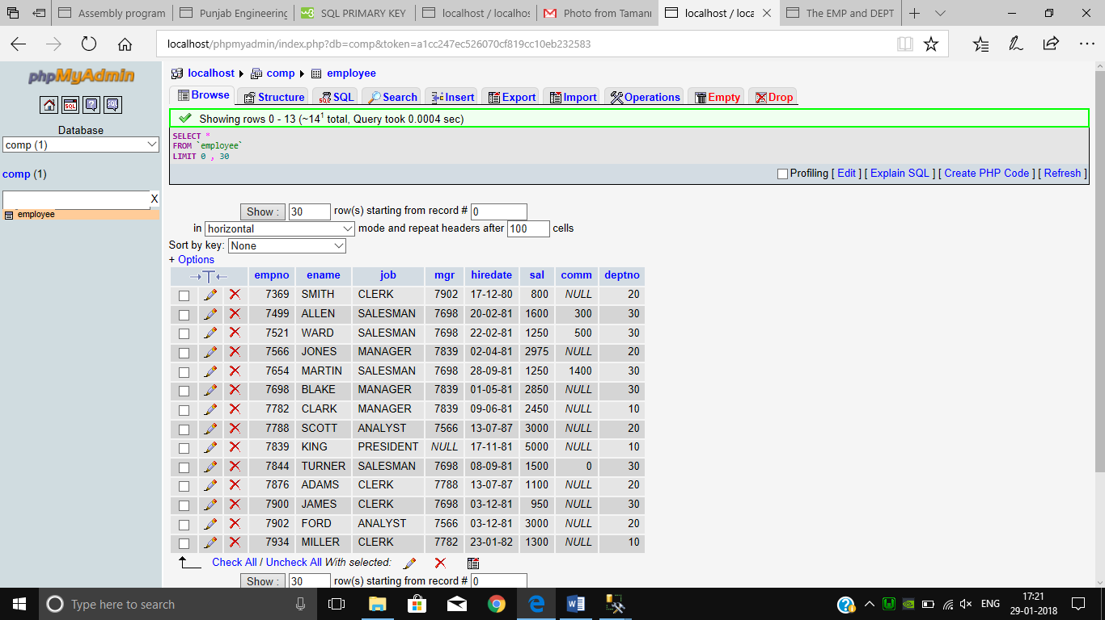

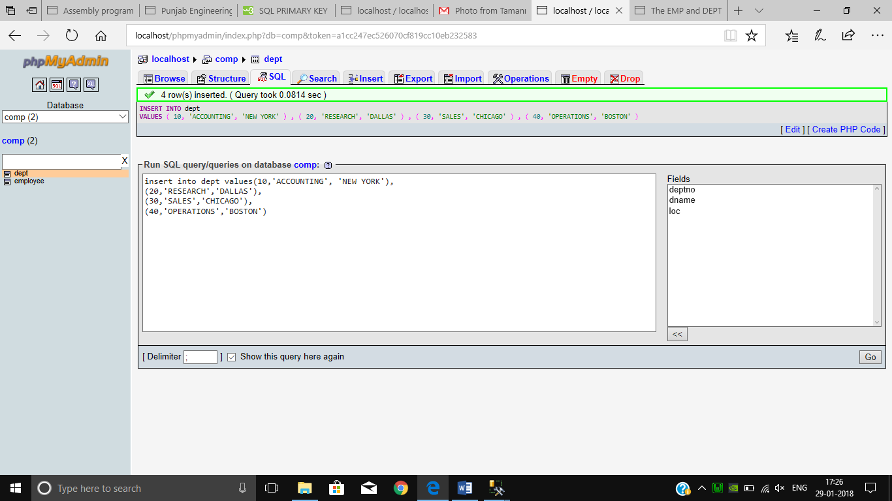

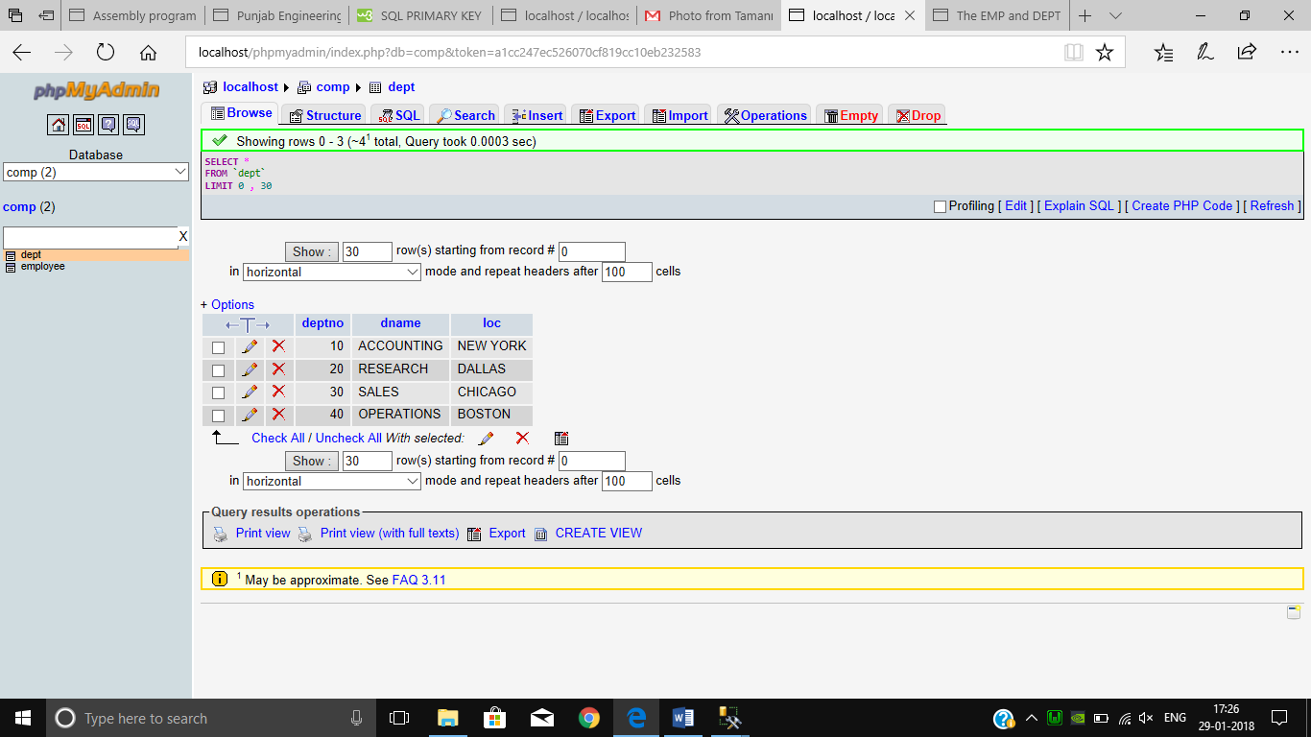

**APPLYING NOT NULL CONSTRAINT**

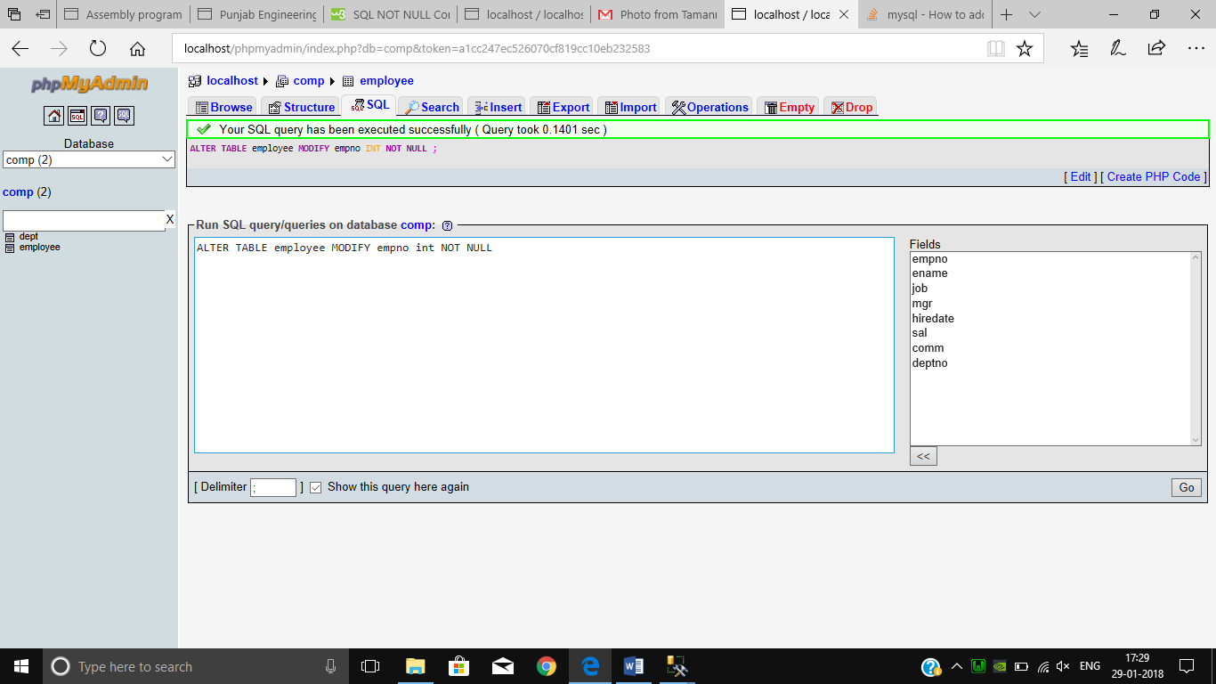

**IF GIVEN NULL VALUE TO IT,IT GIVES AN ERROR**

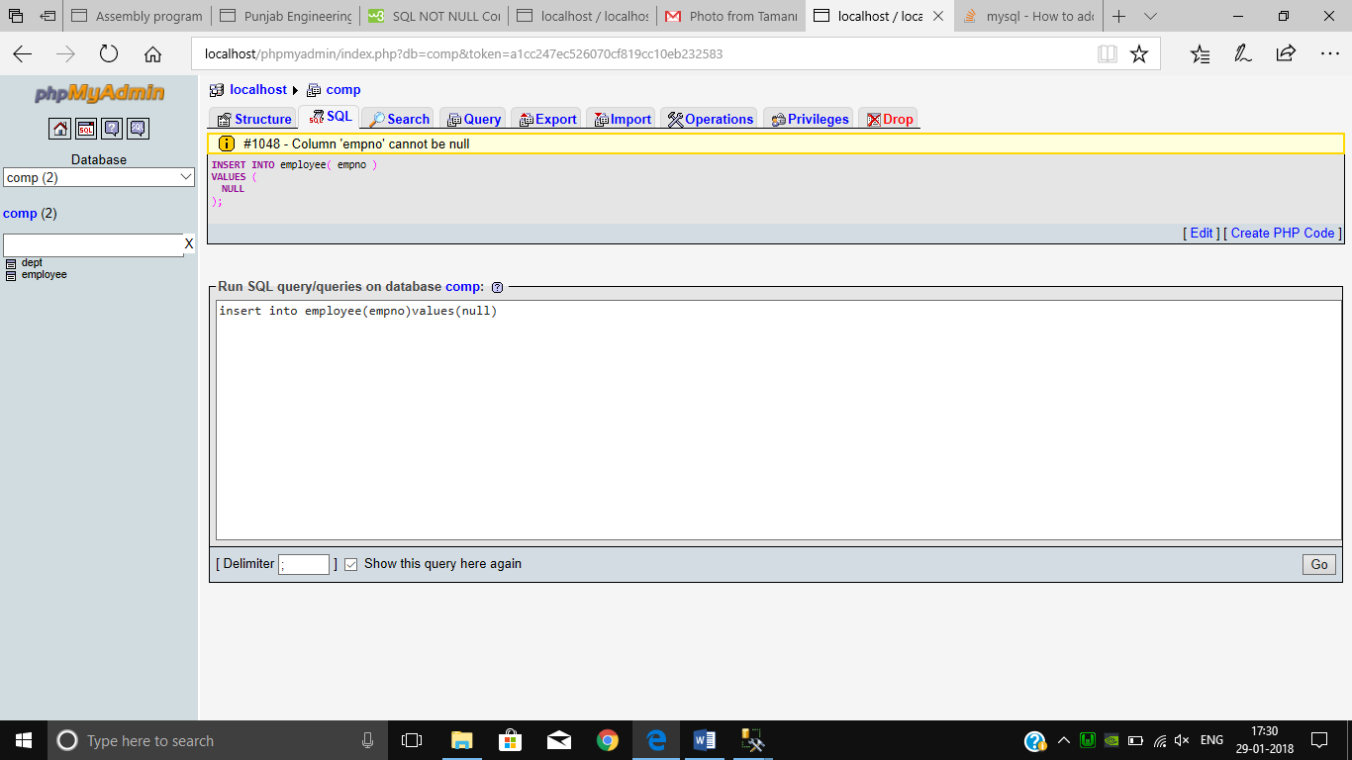

**ADDING UNIQUE KEY**

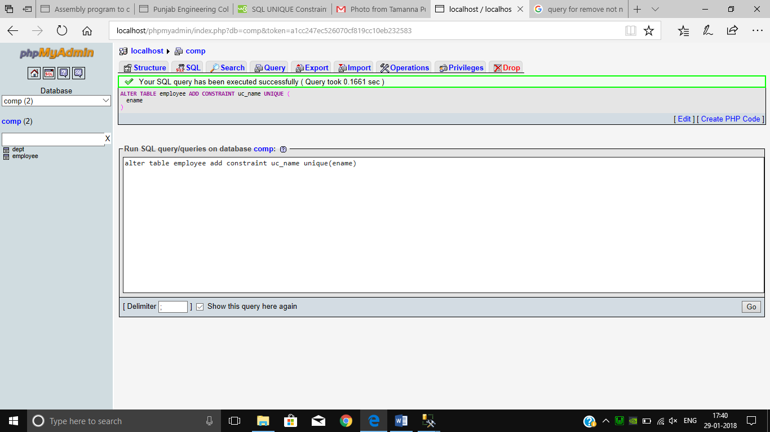

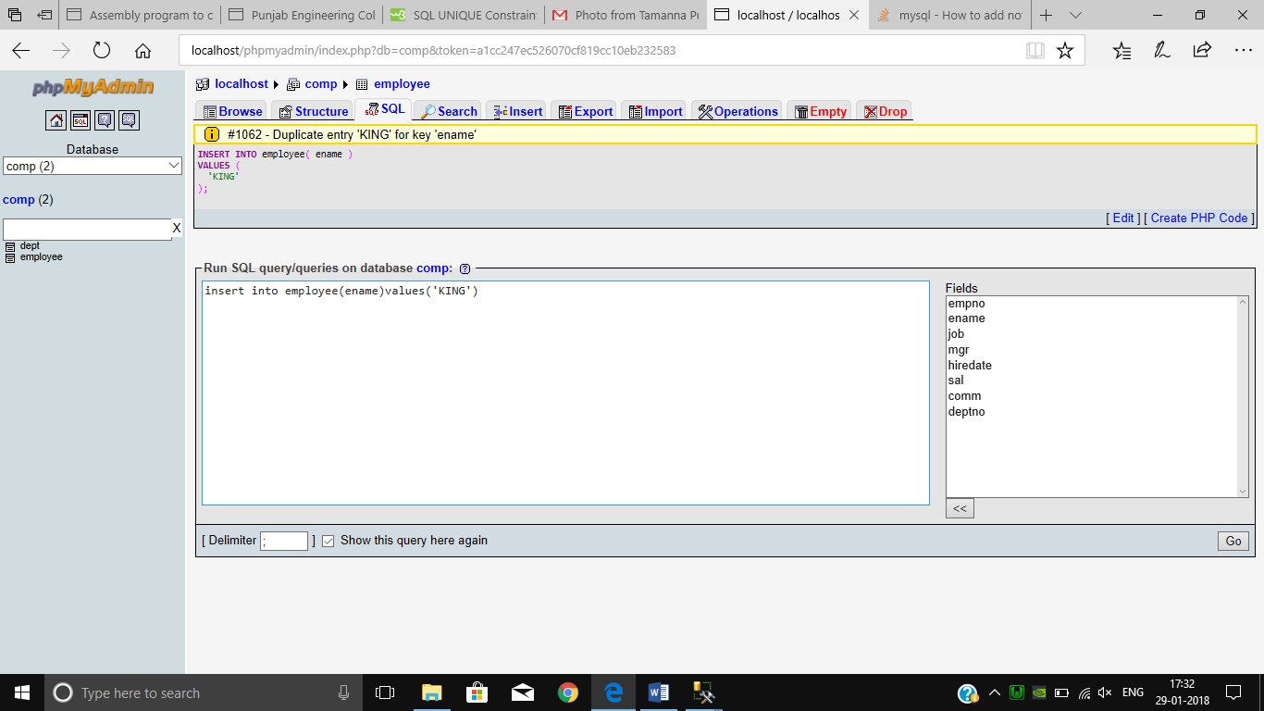

**ADDING PRIMARY KEY**

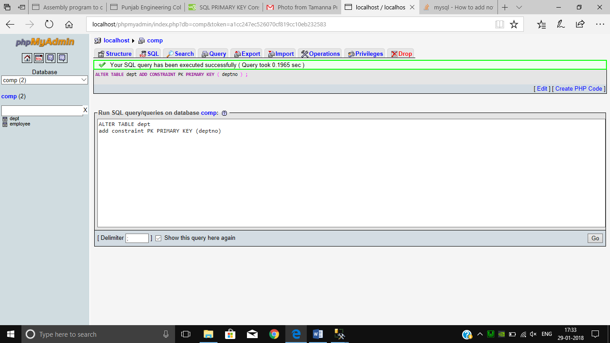

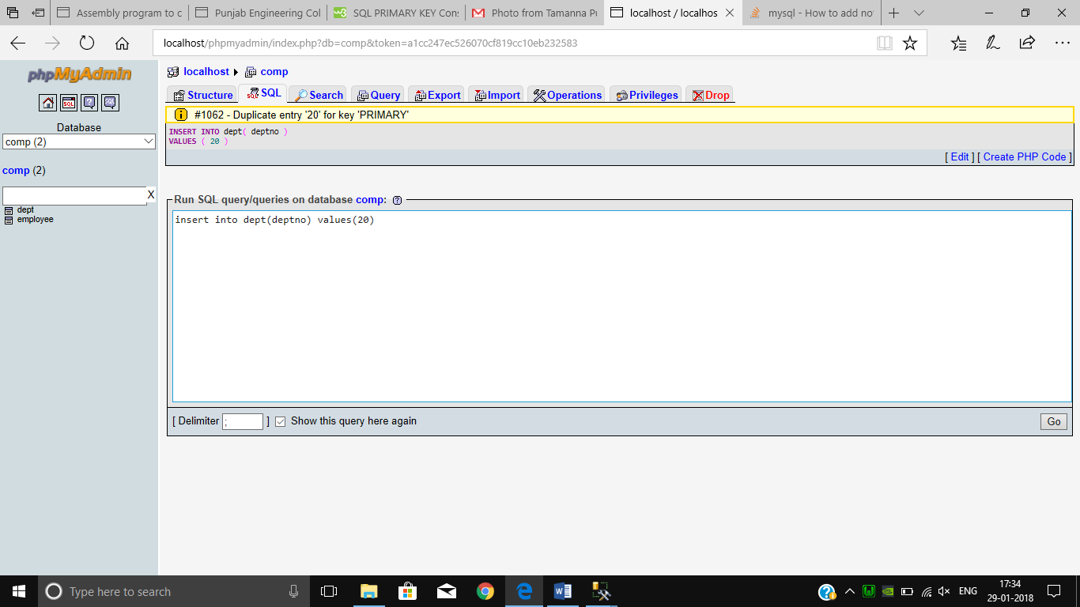

**ADDING FOREIGN KEY**

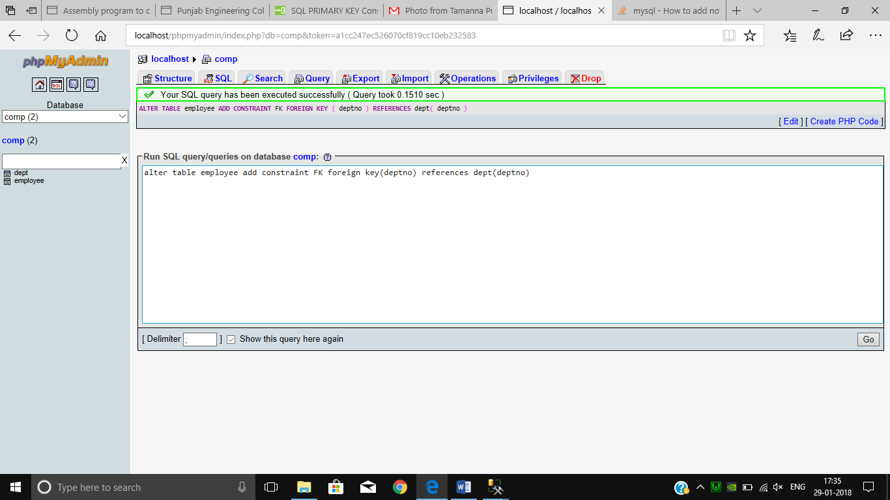

**DROPPING UNIQUE KEY CONSTRAINT**

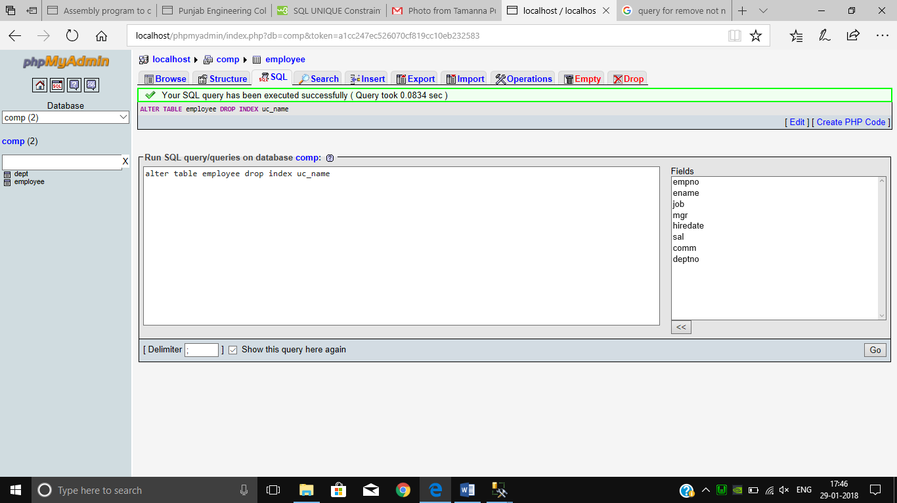

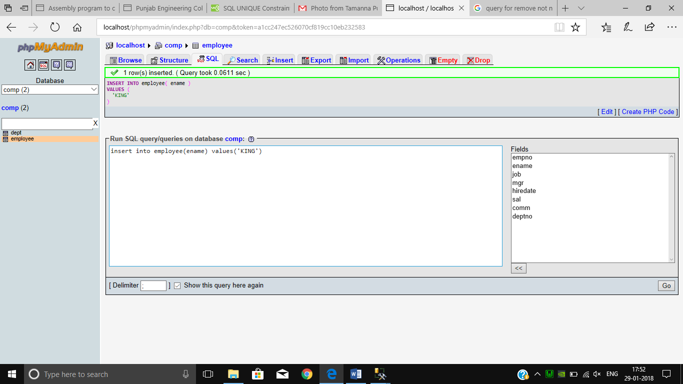

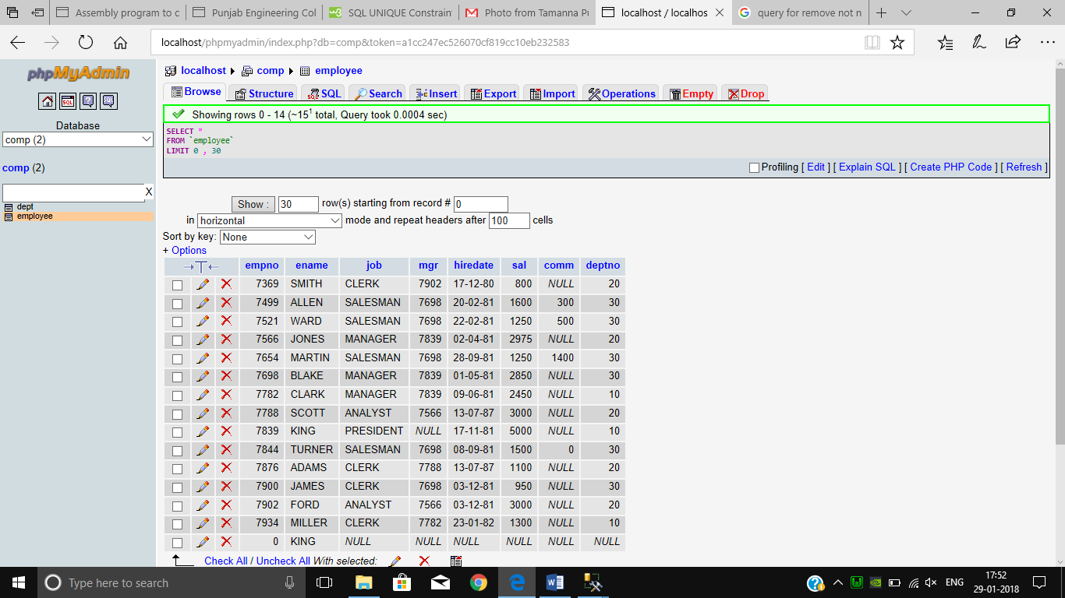

**DROP FOREIGN KEY CONSTRAINT**

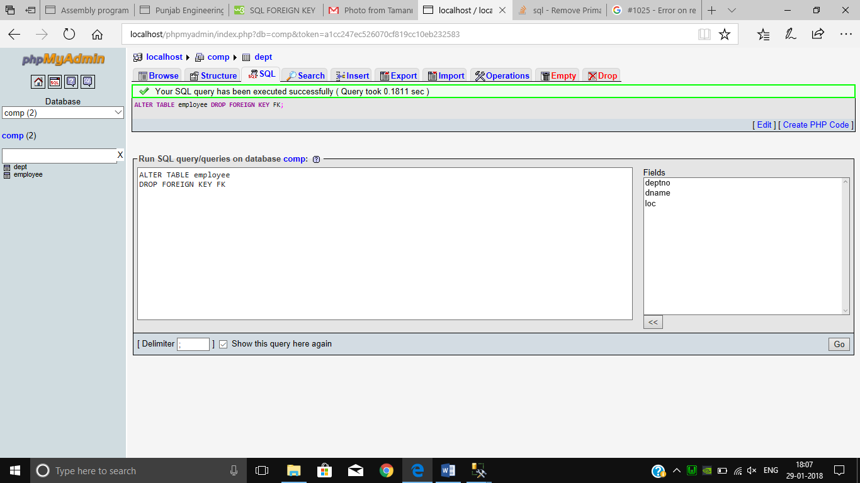

**DROP PRIMARY KEY**

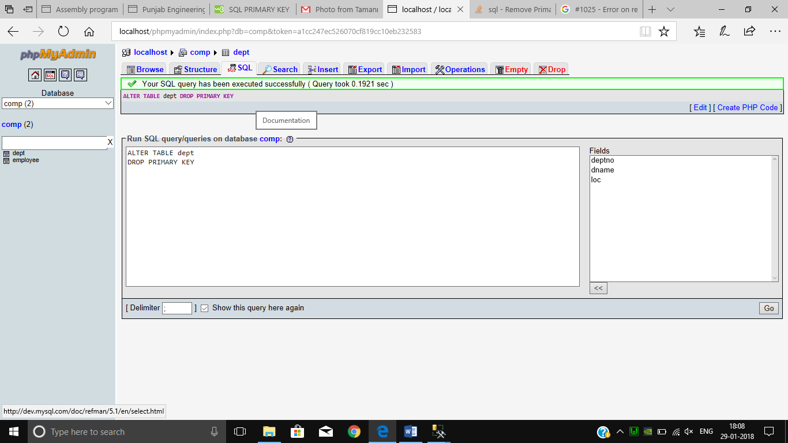

**SHOWING TABLE CONSTRAINTS**

